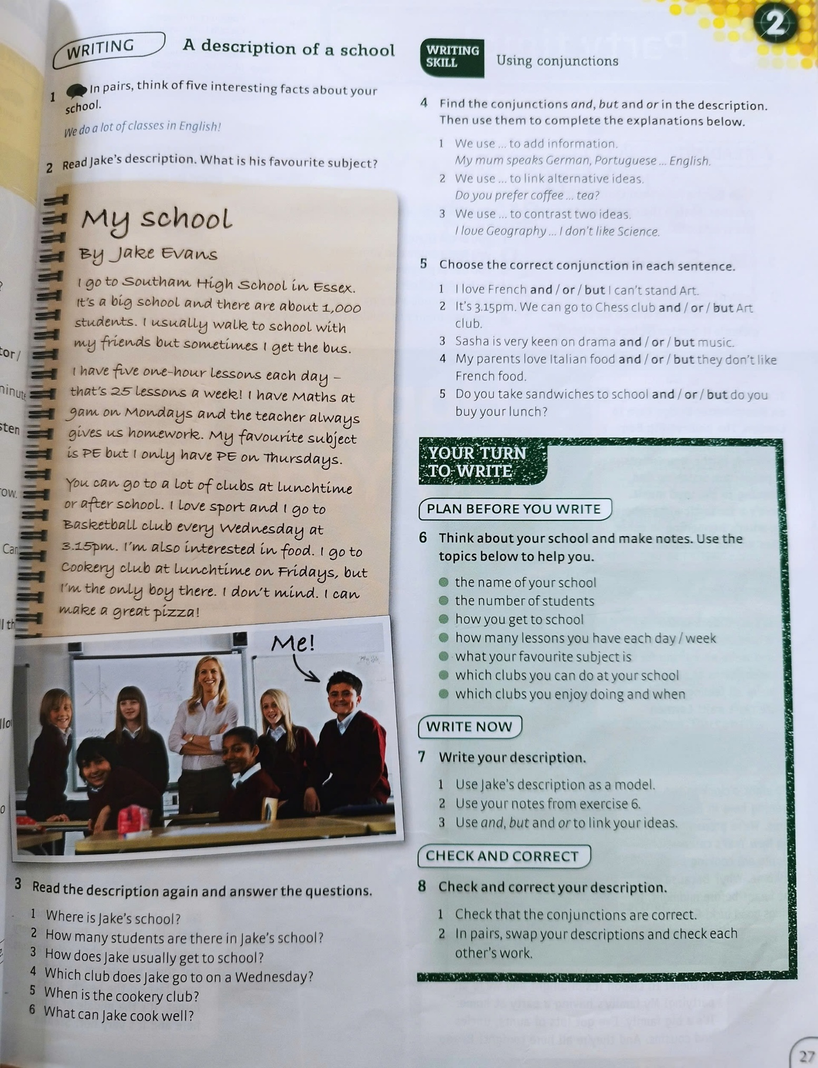

**LESSON PLAN**

**Unit 1: FAMILY LIFE**

**Lesson 2: Language**

**Time : 45 minutes**

**Grade: 10**

**I. OBJECTIVES**

By the end of the lesson, students will be able to:

1. **Knowledge**

- Recognize and pronounce the consonant blends /br/, /kr/, and /tr/ correctly in individual words and in sentences;

- Understand and memorize some vocabularies about family life;

- Identify and know how to use present simple and present continuous.

1. **Skills**

- Main skills: Improve pronunciation, intonation, listening and reading skills.

- Sub skills: Develop speaking and writing skills.

- Use the present simple and present continuous to talk about activities in family life.

- Be collaborative and supportive in pair work and team work.

- Actively join in class activities.

1. **Attitudes**

- Be aware of helping and sharing household chores in their family.

**II. TEACHING AIDS AND MATERIALS**

- Teacher: textbook Global Success 10, lesson plan, powerpoint, gift,...

- Student: textbook Global Success 10, notebook,...

**III. ANTICIPATED PROBLEMS**

- Problem: Ss may not sufficient vocabulary to speak

- Solution: Teacher should provide them with knowledge about volunteer works

**IV. TEACHING PROCEDURE**

|  |  |  |  |
| --- | --- | --- | --- |
| **Time** | **Stages/ Aims/ Contents** | **Teacher’s activities** | **SS’ activities** |
| 5 mins | **WARM – UP: SLAP THE BOARD**  **Aim:** to help ss remember the words they have learned.  **1. homemaker**  **2. breadwinner**  **3. groceries**  **4. housework**  **5. heavy lifting** | - informs the game to ss.  - gives and checks instructions  - lets Ss join the game  - gets the results and decides the winner | - follow T’s instructions  - join the game |
| 7 mins | **PRESENTATION:**  **\*Pronunciation**  **Aims:** To help students recognise and practise the consonant blends /br/, /kr/, and /tr/ in words.  **Task 1:**  **Listen and repeat. Pay attention to the consonant blends /br/, /kr/ and /tr/**    **TASK 2: Listen to the sentences and circle the words you hear.**  **Aim:** To help students practise identifying the consonant blends /br/, /kr/, and /tr/ in sentences.    *Key:*  *1. b 2. c 3. a* | - plays the recording and asks Ss to listen to the words and repeat; tell them to pay attention to the consonant blends. (T can play the recording as many times as necessary)  - makes sure Ss know the meaning of each word.  - checks whether Ss have improved their pronunciation by randomly calling on individual Ss to read the words aloud.  - asks Ss to read all the words once, paying attention to the different consonant blends in the words in each group; checks that Ss understand what the words mean.  - plays the recording for Ss to listen and circle the words with the consonant blends they hear.  - has Ss work in pairs to compare their answers; checks answers by asking individual Ss to read out the words they have circled.  - plays the recording again, pausing after each sentence, for Ss to repeat.  - goes round to offer help and collect common mistakes to correct as a class. | -Ss do as instructed.  -do as instructed.  -Ss practise reading the sentences in pairs |
| 25 mins | **VOCABULARY**  **Aims:**  To make sure that students understand the meaning of some lexical items about household chores.  **TASK 1: match the words with their meanings.**  ***Answer key:***  *1. B 2. D 3. E 4. A 5. C*  **TASK 2: complete the sentences using the words in task 1**.  **Aim:** To give students practice in using the words/phrases in meaningful contexts.  *Key:*  *1. homemaker 2. groceries*  *3. heavy lifting 4. housework*  *5. breadwinner*  **GRAMMAR**  **TASK 1: choose the correct form of the verb in each sentence.** (p.10)  ***Aim:*** To give students an opportunity to revise the use of present simple and present continuous  *Key:*  *1. does 2. is putting out*  *3. cleans 4. is studying*  *5. does*  **TASK 2: complete the paragraph.**  **Read the text and put the verbs in brackets in the present simple or present continuous.**  Key:  1. does 2. is not/isn’t doing  3. is watching 4. are doing  5. is tidying up 6. is trying | -gives clear instructions  - checks answers.  - confirms the correct answer  - has Ss work in pairs; tells them to read the sentences carefully and decides which word in task 1 can be used to complete each of the sentences. T explains that they should use the context clues to decide on the word / phrase, e.g. ‘my mother’ in sentence 1 refers to a person.  - checks answers as a class, then has Ss call out the word they have used in each sentence first.  - confirms the correct answers. T asks Ss to give reasons why they have chosen the word for each sentence, e.g. what context clues they have used.  - asks some Ss to read the complete sentences.  - checks answers.  tells Ss to read the sentences in 4 in Getting Started. T asks them what tense(s) is / are used in each of them.  For example, What does Nam say? Why is he using that tense? *(Nam says, ‘I’m preparing dinner’. He uses the present continuous tense because he is talking about what he is doing at the moment of speaking.)*  - in weaker classes, has Ss read through the Remember! box and checks understanding of the grammar points. T asks some questions to elicit more examples from Ss, e.g. What are you doing now? *(I’m sitting at my desk. I’m learning about … I’m taking notes.) What do you do every day? (I watch TV. I play computer games. I have breakfast, lunch, and dinner.)* - in stronger classes, ask Ss when we use each tense and elicit answers without having Ss read the Remember! box. Then T puts them into  groups to go through the explanations and checks if their answers are correct.  - asks Ss to work in pairs or individually to choose the correct form of the verb in each sentence. T explains that they can use some clues in the sentence to decide on the correct tense form such as adverbs of frequency or phrases of time, e.g. 1: usually; 2: now; 3: every day; 4: today; 5: twice a week.  - checks answers and asks Ss to explain their choices  Teacher check Ss’ answers and asks them to explain their choices (using the clues above).  T asks Ss to look at Remember! box again to master the differences between Present simple and Present continuous.  - T asks Ss to work individually.  T check Ss’ answers and asks them to explain their choices | -work in pairs to discuss and do the matching  -share the answers with the whole class.  -work in pairs to discuss and find the answers  -share the answers with the whole class  do as instructed  *** Ss share their answers with a partner  do as instructed.  Ss share their answers with a partner. |
| 8 |  |  |  |